User guide
Dribdat 2.0
Module 646-2
Projects

Students : Jonathan Schnyder, Caroline Moreira , Anthony Ritz, Daniela Lourenço, Mickaël Coluccia

Teacher : Cotting Alexandre

Product Owner : Oleg Lavrovsky

29th April 2019

Content
Project presentation 2
Vocabulary 3
Dribdat 1 3
Home page – Dribdat 1 3
Dribdat 2.0 5
Home page – Dribdat 2.0 5
Sidebar 5
Project screen 5
Team screen 6
Status screen 7
Ressources screen 9
Footer 9

Project presentation
As part of the 646-2 Projects course, we developed a hackathon web site in vuejs and used the SCRUM methodology.
A version of this website already exists (dribdat 1), we had to be inspired to try to make an improved version (dribdat 2) completed and more simplified.
In this new version we can find several useful features during the realization of a challenge such as the presentation of the project, the information about the team, the currents status about a challenge and the resources and tools used. It can be used for any hackathon.

Vocabulary
Project: A project is a solution proposed to solve the issues of a challenge.

Challenge: A challenge is an idea or an issue concerning a precise theme of the hackathon.

Dribdat 1

Home page – Dribdat 1
The first homepage of the project is the main page of the current version of DRIBDAT (https://hack.opendata.ch). On this page there is the list of all the events. You can choose an event to see the list of projects and challenges

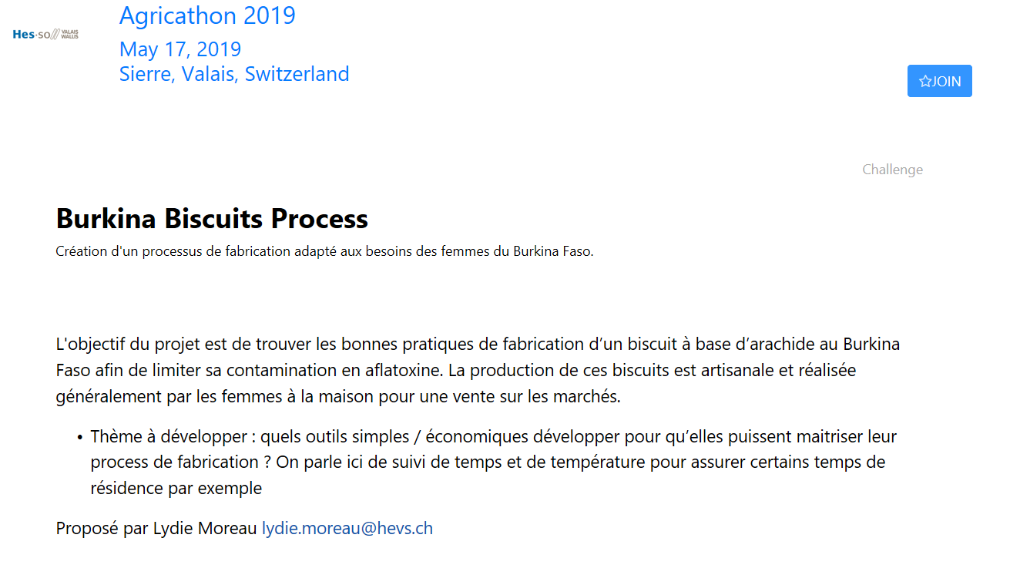
This screen contains the list of challenges and projects. You can choose a project or a challenge to see the details of a project/challenge.
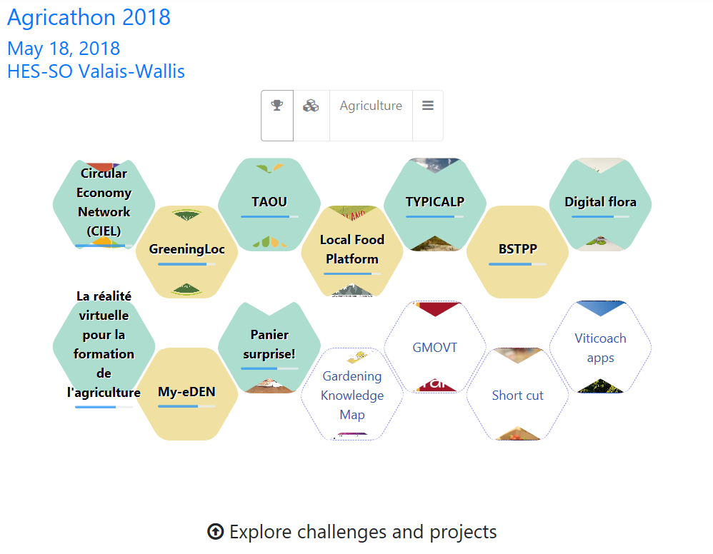
Challenge
Project

On this page we will find in the future a button that allows users to try our new version of DRIBDAT (dribdat 2.0).

Dribdat 2.0

Home page – Dribdat 2.0
On the homepage of our version of "dribdat" is the list of the different projects proposed by the participants of the hackathon.


Sidebar
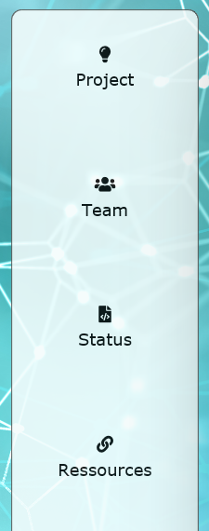
With the sidebar you can navigate between the different pages describe below. The different functionalities are divided into four screens: Project, Team, Status, Resources.

Project screen
This screen gives us general information about the project. First, it has the title of the project which tells us on which project we are. In the center of this screen is a presentation of the project as a video, a slideshow, an interactive demo or just a screenshot. Bellow this presentation there is a little summary with main point about the project.
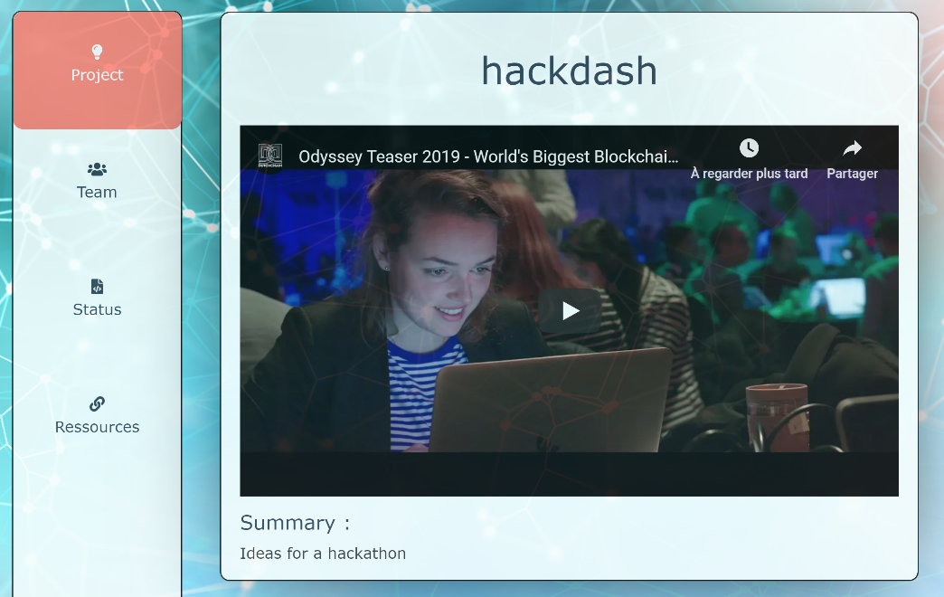

Team screen
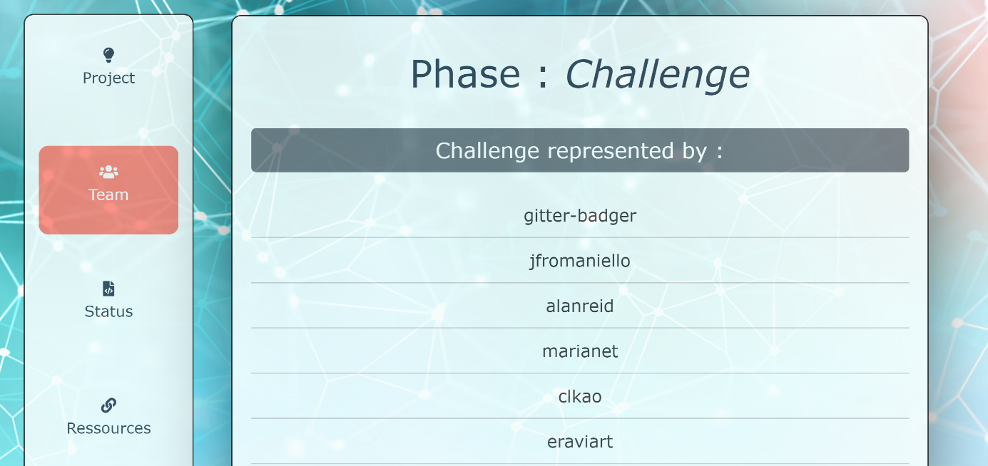
this screen gives information on the organization of the group. First, there is a headline which communicates the intent of the project in a few words. And there are names of each member of the team.

All users can also find the link to the source code at the end of the list of members
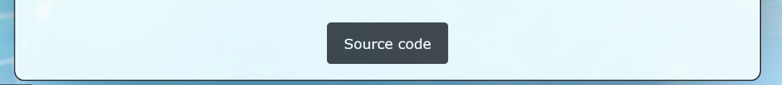

Status screen
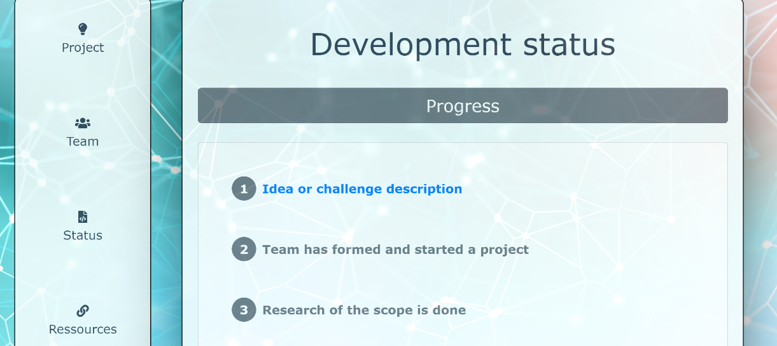
In this screen users can follow the progress of the project. There are three parts: The progress part, the open issues part and contributors part.

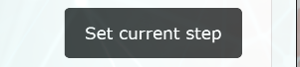
In the "progress" part there is the possibility to leave a feedback. You can choose which step you want to leave a comment with the button "set current step" which will open two buttons "previous step" and "next step" which allow to change step. Then click on "save" to save a comment.

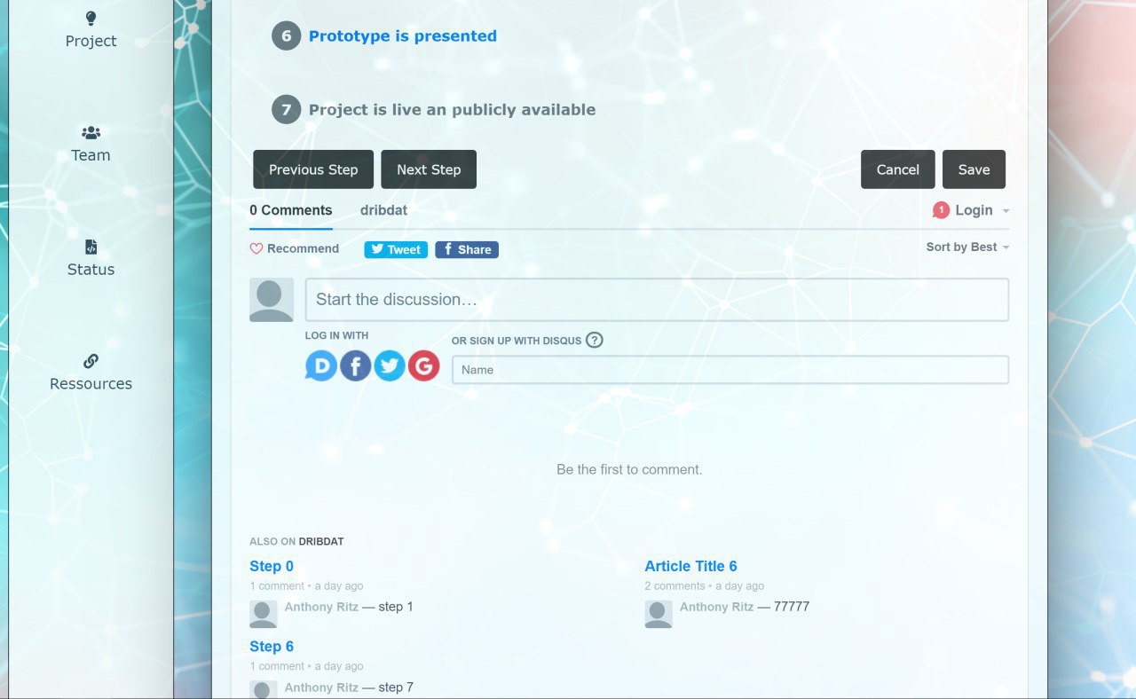

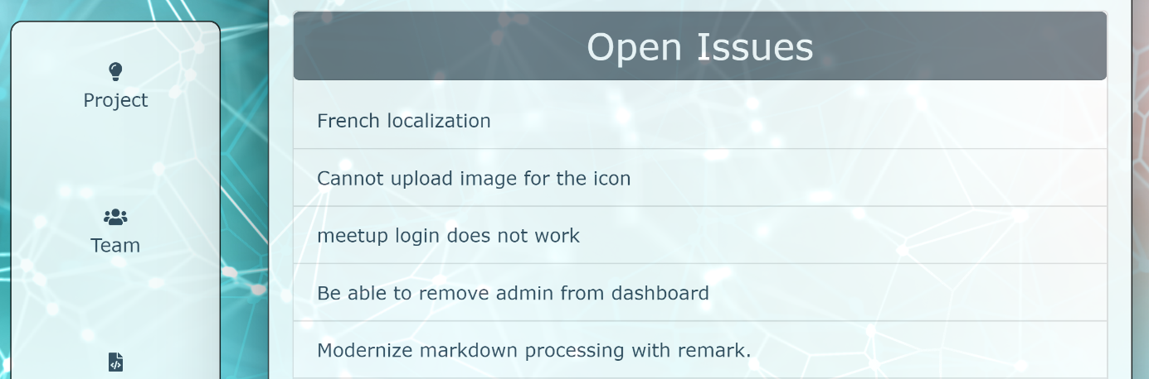
The "open issues" section opens by clicking on the title. This part gives information about the list of current tasks from their bug tracker. The current tasks are indicated at the right part of the task.

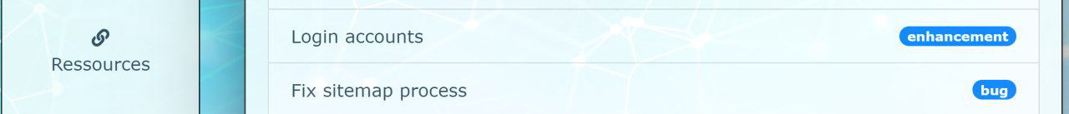

The “Contributors” section opens by clicking on the title. This part indicates graphically the contributions and the progressions for each contributor. Each participant has a graph that indicates their progress. At the top right there is the number of commits that were done.
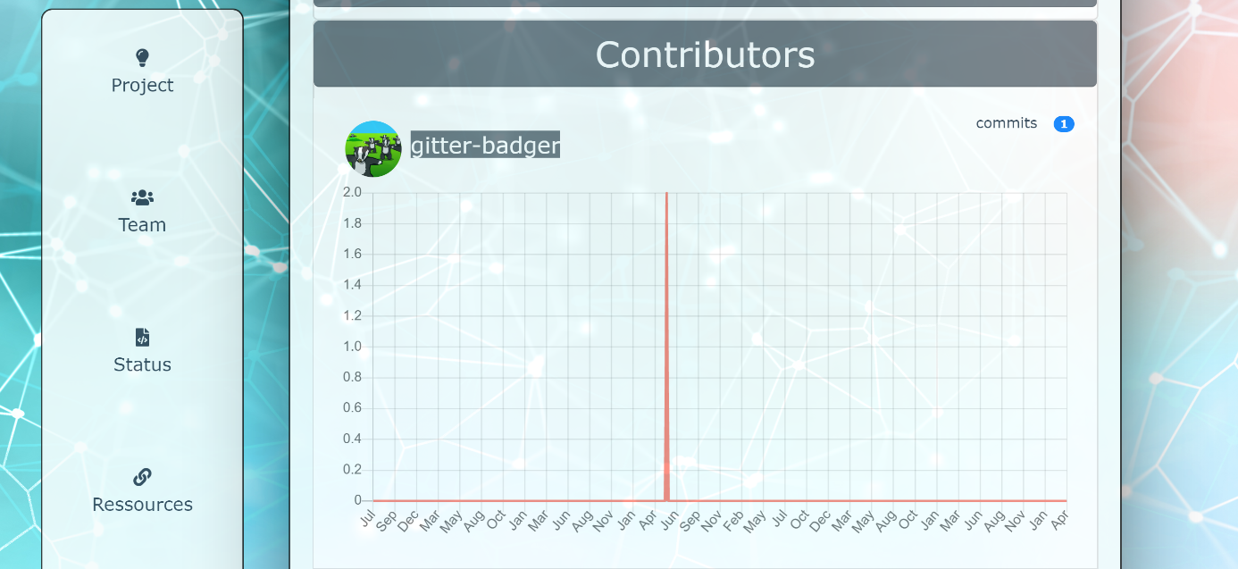

Ressources screen
the resource screen is intended to inform users of resources and tools used for the realization of the project. The resources that are in the resource list are links that redirects to the resource web sites used during project completion.
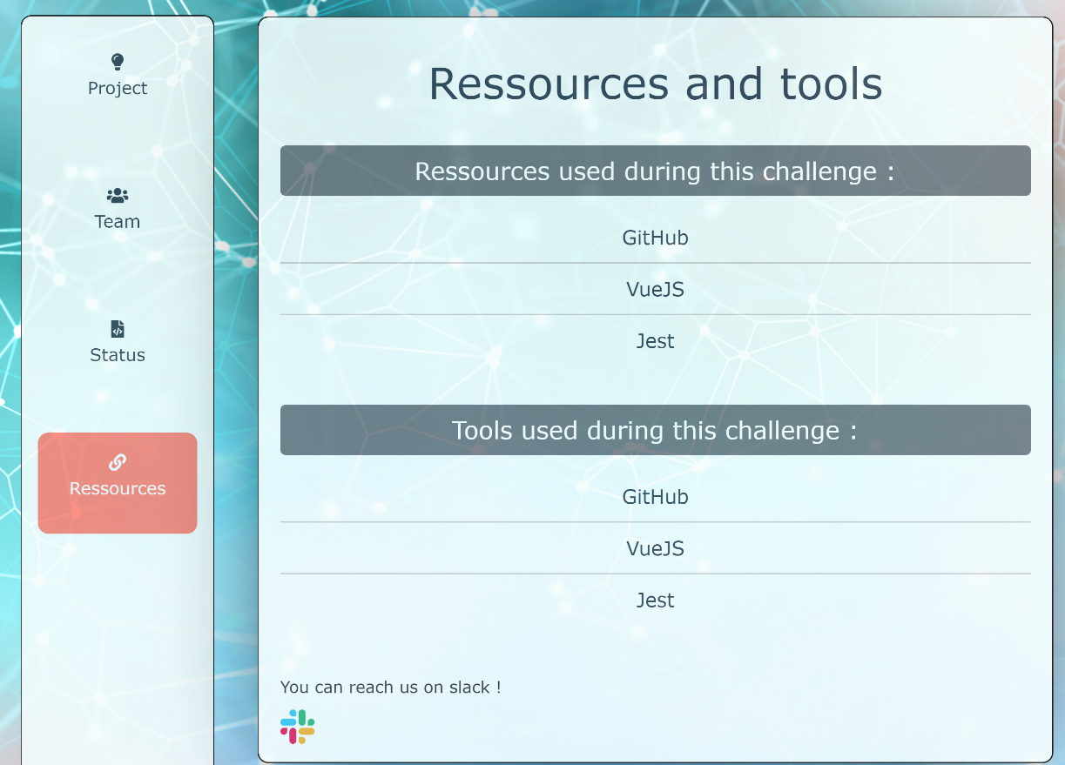

Footer
The footer is present on all the pages, it contains several useful links such as: the links to the patreon, the links to the community, the links which redirect to the home page and the links to the page of ticket store. There is also links to Facebook, twitter and Google+ these three links are links for the event.


